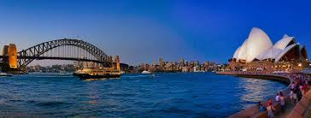**Sydney Harbor Bridge**

Sydney Harbor Bridge (Sydney Harbor Bridge) is the main bridge across Sydney Harbor, the service works trains, motor vehicles, bicycles and pedestrians commercial district downtown Sydney (Sydney CBD) and the North Shore (chronic North Sea). Sydney Harbor Bridge, along with the harbor, the adjacent Sydney Opera House are symbolic images of Sydney and Australia. Sydney Harbor Bridge is nicknamed "The hanger" (English: The Coathangcarngboiwr) due to its arch architecture.

**History**

Under the guidance of architect John Bradfield of the Department of Public Works, New South Wales, the bridge was designed and built by Dorman Long , England, and was inaugurated in 1932. The design of the bridge affected by the Iron Gate of Hell (Hell Gate Bridge), New York city. Sydney Harbor Bridge has the 6th longest main span in the world, is the highest arch bridge in the world, 134 m from the top of the bridge to the river level. At 48.8 m wide, the bridge has the widest span in the world, before the Mann Harbor Bridge in Vancouver was completed in 2012.